**PRODUCT DEVELOPMENT DOCUMENT**

**TEAM 1: Plan It!**

Author: Team 1

Link to website: <http://www.17076460.webdevmmu.uk/Plan%20It%20Website%20-%20Team%201/index.html>

**Table of Contents**

**1 Team name and members** **1**

**2 Rationale for the choice of the Project** **2**

**3 Link to User Requirements (have they been met?)** **4**

**4 Design Decisions Undertaken** **8**

**5 Reference List** **12**

**6 Appendix** **13**

# **1 Team name and members**

|  |
| --- |
| Team 1 - Plan It! |
| Jamie Moore - Project Manager |
| Eve Maher - Deputy Project Manager, creating website content |
| Kiera Beirne - Graphic Designer |
| Alex Mason - Photography and Graphics |
| Zac Powell - Graphic Designer, Website Developer |
| Amy Pickles - Photography, Font and Colour Scheme |
| Kevin Dyson - Website Developer |

# **2 Rationale for the choice of the Project**

The chosen prototype for this project is a website for young and mature students and also couples, to be able to plan days and nights out. The name for the website was decided to be ‘Plan It!’. The team had to negotiate on the website name as initially there were three possibilities ‘Plan It’, ‘Day Designer’ and ‘Sorted’ however at the end, the team agreed that ‘Plan It’ was the most appropriate brand name. The topic for the website, based on being able to look through different bars, clubs, restaurants etc to plan a specific day or night, was chosen because it fits closely with university students and is also a relatable age group for the team.

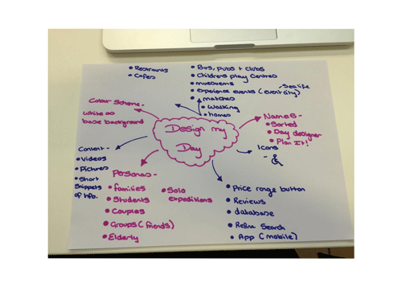

For this project, it was decided to keep the amount of web pages minimal, between six and ten, so that more time could be focused on the quality of the website rather than how many pages are created. While researching this topic for the website, it was noticed that there are many few websites that caters for the students and couples for a great night out and also execute this well. Many of these websites have poor designs and can be quite daunting to use. This is why, as a team, we wanted to create a website that is easy to use and has a design that will feel welcoming but also fun. As the members of the team could relate to the target audience as they are students themselves and many of them being in relationships, they understood the uses and qualities that many of the audience are looking for.

Despite this, multiple research studies were conducted to see what the target audience would prefer and how they would view the ideas for the website development. The team shall conduct multiple research methods including a tree jack and a card sort in order to gather the necessary information we need to further develop our website.

To ensure that the website is produced on time with the deadline and that it is to the highest quality the team could possibly produce, the team needed to be organised, work efficiently and communicate effectively with each other. With members of the team having other unit deadlines and time being limited together, it was vital that we stay up to date and organised so that the project would be a success. This is why the team decided to take on an agile project management framework approach. (Layton, 2012) refers to agile project management as a style of project management that focuses on continuous improvement of the projects product and processes, scope flexibility, team input and delivering well-tested products that reflect the customers needs. This applies to all aspects of the teams project as it is a website. In the building process of the website, there was constant improvements and team input to ensure everyone was happy with the product and that it all reflected back on the needs of the user.

To further ensure that this project is managed efficiently and the team stay informed and on top of all tasks required, some elements of Scrum were adopted. (CollabNet, no date) refer to Scrum project management a framework that embraces iterative and incremental practices, helping organisations deliver working software more frequently. The team wanted to adopt some activities from Scrum project management which was taking part in weekly sprint, with each sprint consisting of a daily scrum. (Scrum.org, no date) state that a daily scrum is a fifteen minute boxed off event for a development team and that the purpose of this event is for the development team is to share with each other what they’re working on, what has been completed, and what needs to be done. So for the team producing this Plan It website, this activity was crucial for us staying organised and on top of the project. It also ensured the work was done to a high quality and that the team were happy with the progress of the project. Adopting this mindset and project management framework proved effective for the Plan It team as the final product was to the teams standard and the users needs as well as the project being delivered in plenty of time to the deadline.

# **3 Link to User Requirements (have they been met?)**

Plan It! is a website that allows people to plan their day for a specific place and the team wanted this website to reach a wide target audience. To ensure that the team produce a website that is useful and relevant for the users, extensive user research and various user research methods would need to be adopted. (Mortensen, 2019) states that user research covers a wide range of methods, but what it does is place people at the centre of your design process and products.

The first step of the user research process was to hand out BBC user research template documents to as many people as possible and to a wide age range of people. The purpose of this document was to find out what users like about the idea of this website, what they dislike, and more ideas on what they would need if they were to use the site. After handing out seventeen of these documents the team was able to summarise the users into three categories, which were young students, mature students and couples. This research approach also helped the team determine which types places will be recommended to the users so that they can plan their day for it. The young students stated that they would like lively and affordable places, the mature students stated that they would like nice restaurants or bars and the couples suggested that they would like places to go on a date to or a nice bar.

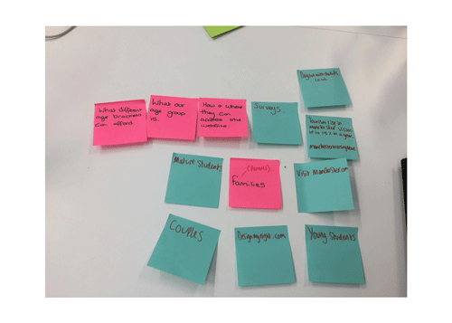

From this the team really needed to delve further into the users needs and to do this they conducted a qualitative research method and asked some of the users to take part in a focus group and perform some short research exercises. (Sheldon, no date) defines qualitative research as an in-depth exploration of what people think, feel and why they do the things they do. Qualitative research is about understanding why people behave the way they do. So, for the users who will visit the Plan It website, the team want to understand how would the users would interact with the site and why. It is crucial that users can find relevant information easily and can navigate through the site seamlessly.

Qualitative Research Methods

From the results of the user research template documents the team give to the users, the team were able to scout various locations and pick relevant places that best suited the users. In addition to this, were able to begin bringing ideas forward on the type of content the website would need. Furthermore, to see if the content was right for the user, they needed to get the users opinion and see how they responded to the content and why they respond the way they do. To do this, the team conducted a focus group that consisted of users from each group they were categorised in, which was young students, mature students and couples. Experience UX (no date) define a focus group as a moderated group discussion of around 6-10 people and that they are used to gather target audience opinions about certain products, services or concepts. The purpose of the focus group that the team will be conducting is to ask users to take part in two short exercises, which is a card sorting exercise and a tree jacking exercise. (Morgan, 1996) suggests that focus groups are a popular technique for gathering qualitative data and the advantages of a focus group can be maximized through careful attention to research design issues. With the users taking part in these two exercises, the team were then able to produce website designs specifically tailored towards the user.

Card Sorting Exercise

Smashing Magazine, (no date) refers to card sorting as the process of writing down all the content you want to include in your website onto cards and ask participants to organize the cards into groups that make sense to them. In the focus group that the team conducted, the users were asked to take part in an open card sorting exercise on Optimal Sort, which is a tool on Optimal Workshop that allows people to organise an open card sort online. The purpose behind this open card sorting exercise was for the team to be able to analyse the results of how the users organise the cards and this allows the team to build a suitable information architecture for the website. From the results of this card sorting exercise they were able to build a suitable navigation and structure relevant together throughout the website. In addition to this the team needed to further test if a user could find specific information nested within the navigation and to do this, the team asked the participants in the focus group to then take part in a tree jacking exercise.

Optimal Workshop, (no date) defines a tree jacking exercise as a usability technique for evaluating the findability of topics in a website.

As the subscription of this account is free, it only allows you to set three tasks. In this picture is the tasks we’ve set for the participants to complete.

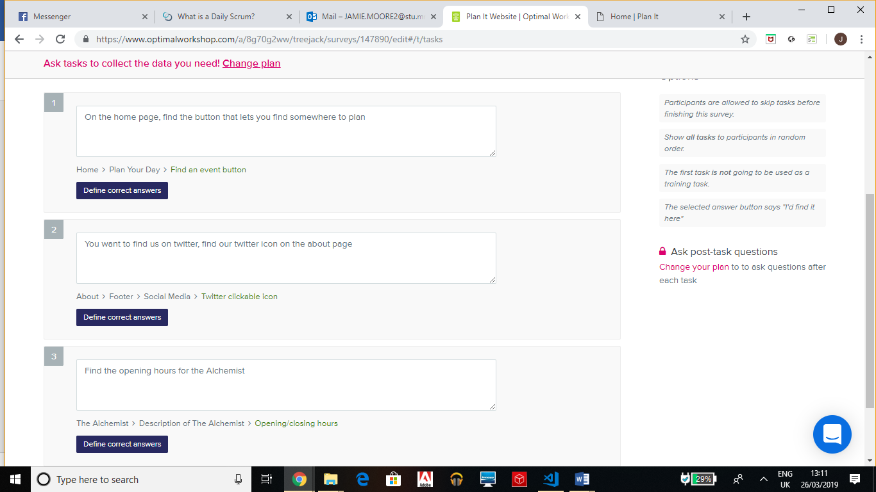

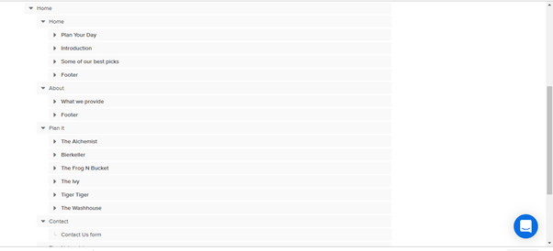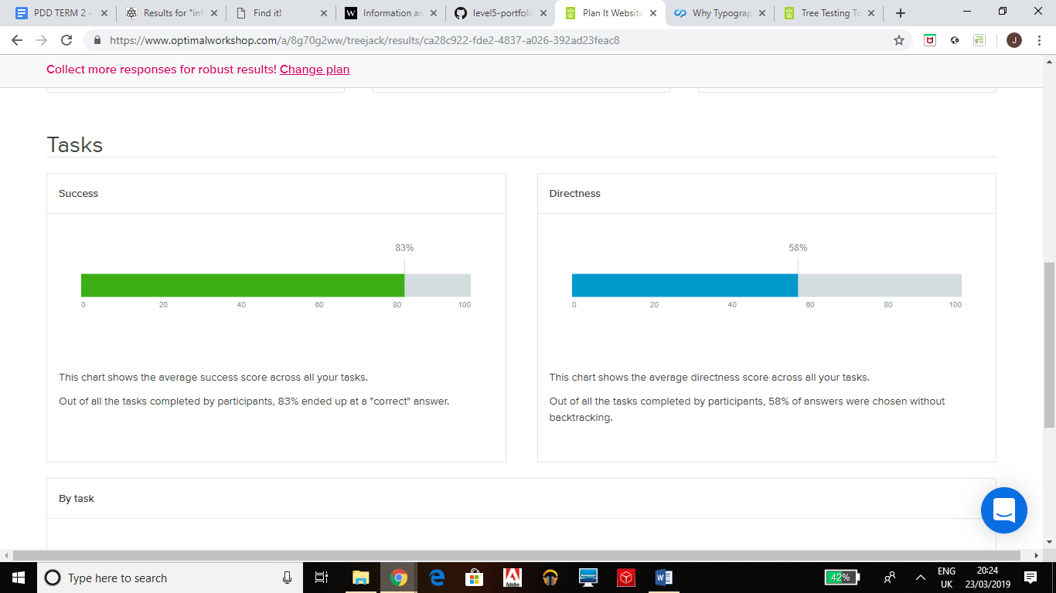

Above is the structure of the website the team were able to come up with as a result of the card sorting exercise. The participants task in this tree sorting exercise is to look at each task that has been set and click through the structure above to find the necessary information. The purpose of this exercise was for the team to analyse how easy or difficult users found it performing each task as it allows them to build the most relevant information architecture. (Jacob and Loehrlein, 2009) refer to information architecture as ease of access to relevant information on a website. After the focus group, the team all discussed the results of the open card sorting and tree jacking exercise and how to use these results to build to build the Plan It website so that relevant information is easily accessible and findable for the users.

# **4 Design Decisions Undertaken**

**Navigation**

Since the navigation bar is to be part of the websites aesthetics, the team have chosen to have no background for the navigation bar and to have only the buttons showing within the website to make the feel as a whole product. It was also decided that the colour scheme was to be stuck to whilst using bright colours to make these stand out and make it feel like the background is in the background and that the navigation buttons are lifting off from the website. Following Irvine’s samples of websites that show great innovative and fun ways of using navigation, the navigation is designed to flow on to the website (Irvine, no date). The different web pages that are included in the navigation bar are: Home, About, Plan it and Contact, the team kept the amount of web pages minimal to maintain a simple set out which is easy for the viewer to flick through.

**Colour Scheme and Logo**

After using research from multiple different websites that share the same objective as the team’s, the team chose to pick colours that would represent the proposed business image. This meant using images with a dark background but have accents with light neon colours. For this reason, the team chose the colour schemes of dark backgrounds and light neon coloured navigation with buttons that match the company’s presence. Following the information from Nayomi we have gone with ‘Bright Accent Colours’ (Chibana, no date). The team chose to use the colour purple as the main colour for their logo and website, as, according to data from Hynes, of the Journal of Brand Management (2009), purple is often associated with reliability, excitement and playfulness. These traits are all things the team wanted the to website to be. Logos are the holy grail for every business to ensure there is instant recognition (Shadbolt, 2015). For the logo design, lots of different aspects had to be considered regarding the design of the logo including, shapes, typeface, colours, and resemblement. The team wanted the logo design to be simplistic but interesting at the same time, to entice the chosen target to go on the website and use it to plan their day/night(s) out.

The following logos were the team’s initial ideas for the logo design:

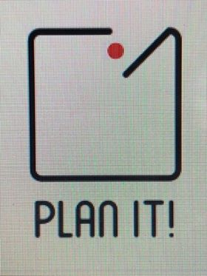

The team’s final decision for their logo is the logo shown below. This is because it is simple, yet effectively portrays the desired message. The team chose a brighter purple to the background on the website, this was done to make it stand out but still remain cohesive to the rest of the website.



**Font**

When deciding on what font to use, other websites were looked at and analysed which are similar such as ‘Design My Night’ - this company use a basic Serif font for all of their main body text, which makes their website look so sleek whilst being easy to read and attractive. Based of this evidence, it was decided to make the font for the Plan It website like this, and it was chosen to use ‘Domine’ for the main body text and Nunito for all of the headers.

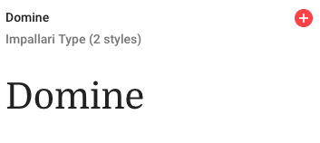

**Promotional Video**

For the website, the team decided that it would be ideal to include a short feature/promotional video for users to get an insight of the places and experiences that are offered. Promotional videos are a great way to show off the culture of a brand/company and sets its personality (Page, 2015). According to Page (2015), 64% of consumers are ‘more likely to buy a product after watching a video about it…’ therefore it is ideal for this type of website to have a video to give allow users an quick, effective indication of all the different types of places they could go to.

The video shows shots of some of the places presented on the website including: The Alchemist (Cocktail Bar and Food), Tiger Tiger (Club), Frog N Bucket (Comedy Club), The Wash House (Cocktail Bar), The Manchester Museum and Treetop Adventure Golf. All of these places are located in the City of Manchester, which promotes the prime locations for the Plan It website.

**Photos**

For the website, a variety of different photos were taken, using a Canon EOS 700D DSLR Camera to reach maximum quality; these were all taken by members of the team to avoid using other people's photos (copyright) and to ensure all photos were original and unique. These photos were then edited and optimised for the web, so when the photos load up on a computer they won't take that long as they’re not as big of a file size. The best images were chosen that would best suit each venue in order to encourage more people to go to these places. For the website, two photos were used for each venue. This was to prevent the website from overloading with images and it was to prevent clutter on the website there was only a main image to show what the place looks like so someone can easily find it when they go there. The group decided they wanted to go for a more simplistic layout so less pictures would achieve this, as they did not want their website users to feel overwhelmed with the amount of content.

**Website Designs**

There drawings were the original designs for the website. These were used to make the final product, the website. Rosen, (2004) states that “Adopting a minimalistic approach to the design of the home page with eye-catching … graphics … draw the web surfer further into the site”. Using this, the team were able to design the site to be simplistic and easy to use.

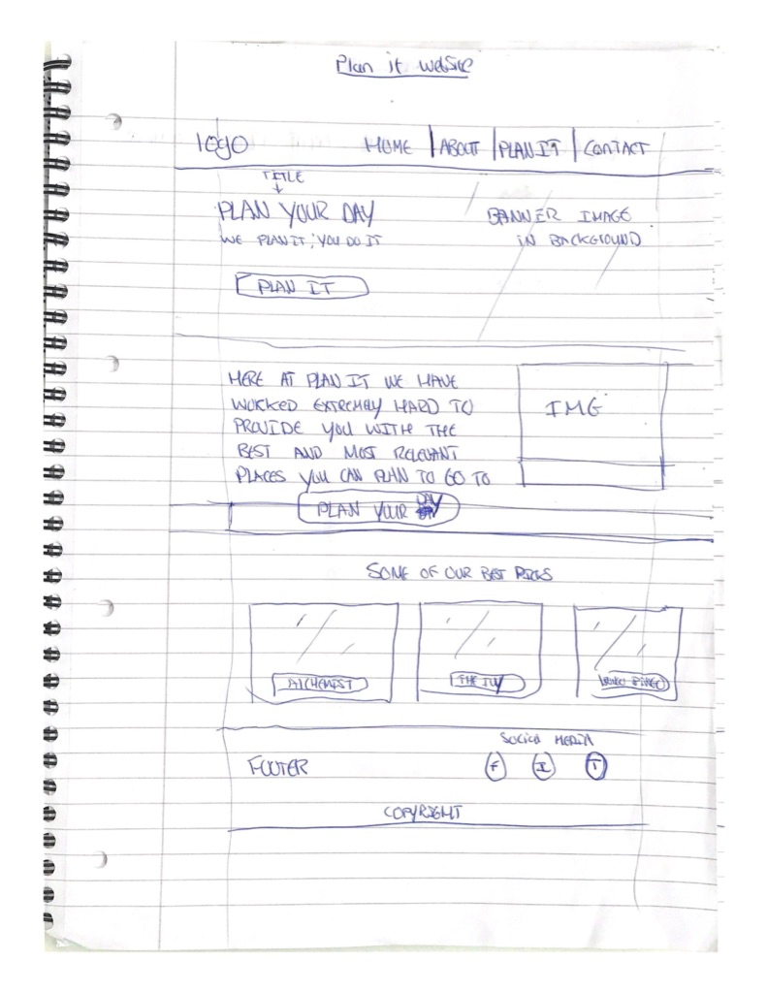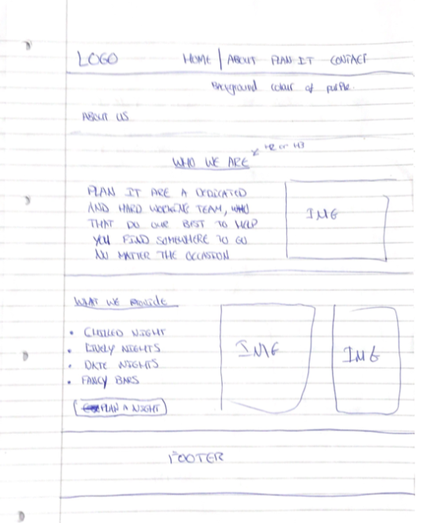

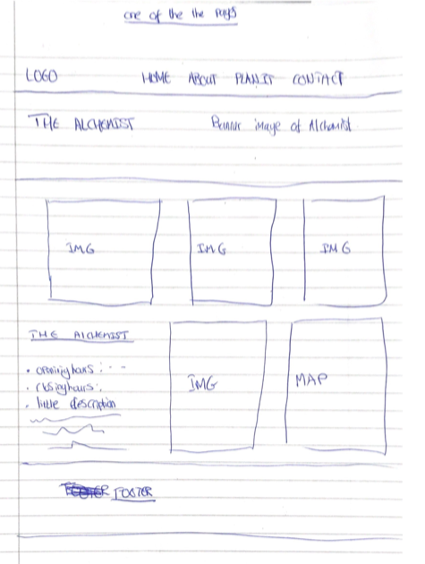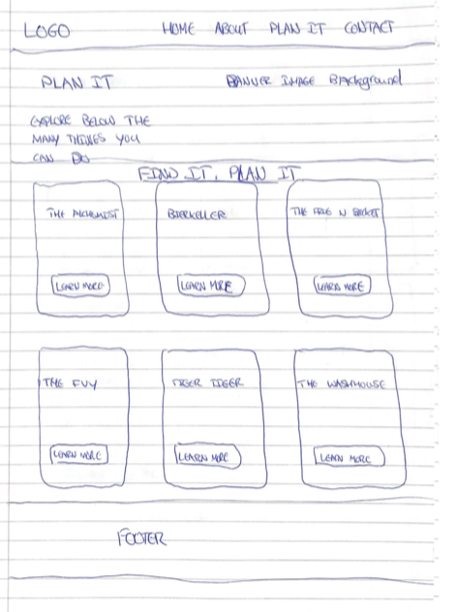

# **5 Reference List**

Chibana, N. (No date) *50 Gorgeous Color Schemes From Award-winning Websites.* [Online] [Accessed on 19th March 2019] <https://visme.co/blog/website-color-schemes/>

CollabNet. (No Date) *What is Scrum Project Management.* [Online] [Accessed on the 26th March 2019] <https://www.versionone.com/scrum-project-management/>

Experience UX. (no date) *What are focus groups?.* [Online] [Accessed on 16th March 2019]<https://www.experienceux.co.uk/faqs/what-are-focus-groups/>

Hynes, N. (2009) ‘Colour and meaning in corporate logos: An empirical study’ *The Journal of Brand Management,* 16(8) pp. 545-555

Irvine, S. (No date) *23 Great Examples of Innovative Navigation for your Inspiration* [Online] [Accessed on 19th March 2019] <https://www.dtelepathy.com/blog/inspiration/23-great-examples-of-innovative-navigation-for-your-inspiration>

Jacob, E.K., loehrlein, A. (2009) ‘Information Architecture.’ *Annual Review of Information Science and Technology*, 43(1) pp. 1-64.

Layton, M.C. (2012) *Agile Project Management for Dummies.* New Jersey: John Wiley & Sons.

Morgan, D. (1996) ‘Focus Groups.’ *Annual review of sociology,* 22(1) pp. 129-152.

Mortensen, D. (2019) *User Research: What it is and why you should do it?.* Interaction Foundation Design. [Online] [Accessed on 15th March 2019]<https://www.interaction-design.org/literature/article/user-research-what-it-is-and-why-you-should-do-it>

Page, B. (2015) ‘6 reason you need to use Video Marketing.’ *Inc.* [Online] [Accessed on 19th March 2019] [https://www.inc.com/bubba-page/6-reasons-to-use-video-marketing.ht](https://www.inc.com/bubba-page/6-reasons-to-use-video-marketing.html)

Rosen, D.E. & Puriton, E. (2004) ‘Website design: Viewing the web as a cognitive landscape’ *Journal of Business Research,* 57(7) pp. 787-794.

Scrum.Org. (No date) *What is a Daily Scrum.* [Online] [Accessed on the 26th March 2019] <https://www.scrum.org/resources/what-is-a-daily-scrum>

Seldon, R. (no date) *Qualitative or Quantitative – which method is for you.* [Online] [Accessed on 15th March 2019]<https://www.marketingdonut.co.uk/market-research/qualitative-or-quantitative-which-method-is-for-you>

Shadbolt, P. (2015) *How important is it for a company to have a great logo?* BBC. [Online] [Accessed on 15th March 2019]

<https://www.bbc.co.uk/news/business-32495854>

Smashing Magazine. (no date) *Card Sorting Beginners Guide – Improving Your Information Architecture.* [Online] [Accessed on 16th March 2019]<https://www.smashingmagazine.com/2014/10/improving-information-architecture-card-sorting-beginners-guide>

# **6 Appendix**

Participant Information Sheet

Plan It Website

**1. Invitation to research**

We are students at The Manchester Metropolitan University that have been given the task managing a project and producing a fully functioning product, to which we have chosen to produce a website. For this website we need user research from people in order to produce the most relevant and useful website possible.

We would to invite you to take part in a focus group and participate in a short card sorting and tree jacking exercise. We are making a website that enables you to plan a day or night out somewhere based on your preferences. Our research project is a card sorting exercise in which we will give you numerous cards with the contents of what will be on our website and your job is to group relevant cards together and give them a label name.

**2. Why have I been invited?**

We have chosen you to participate in this research project because with your feedback, we can produce the most relevant and useful website possible for you and our intended audience. We have chosen specific participants that are within a similar age range and from the feedback of this age range we can find the most relevant places for each age range.

**3. Do I have to take part?**

It is up to you to decide. We will describe the study and go through the information sheet, which we will give to you. We will then ask you to sign a consent form to show you agreed to take part. You are free to withdraw at any time, without giving a reason.

Plan It Website

**4. What will I be asked to do?**

We are asking you to take part in a focus group and participate in a card sorting exercise. This will last a maximum of around twenty minutes. You will only need to take participate in this focus group once when completing the card sorting exercise. After this card sort will ask you to take part in a short tree jacking exercise which is simply responding to a task, we set by finding a piece of information from a structured navigation that we made as a result of the card sort. All of this will take a maximum of thirty minutes to complete.

**5. Are there any risks if I participate?**

There are no risks associated with taking part in this focus group.

**6. Are there any advantages if I participate?**

We will make sure we travel to you to conduct this focus group but in any other case you will be compensated for your travel and meal costs. The research we gather from you participating in this focus group will enable us to provide the most relevant website for your use if this website were to ever go live.

**7. What will happen to the samples that I give?**

From all the participants who take part in this focus group, we will gather and group specific age range together and collate them into specific user personas. A user persona is a made-up person who shares the same interests and goals as the participants whose age range from 18-21 for example.

Plan It Website

**8. What will happen with the data I provide?**

When you agree to participate in this research, we will collect from you personally-identifiable information.

The Manchester Metropolitan University (‘the University’) is the Data Controller in respect of this research and any personal data that you provide as a research participant.

The University is registered with the Information Commissioner’s Office (ICO), and manages personal data in accordance with the General Data Protection Regulation (GDPR) and the University’s Data Protection Policy.

We collect personal data as part of this research (such as name, telephone numbers or age). As a public authority acting in the public interest we rely upon the ‘public task’ lawful basis. When we collect special category data (such as medical information or ethnicity) we rely upon the research and archiving purposes in the public interest lawful basis.

Your rights to access, change or move your information are limited, as we need to manage your information in specific ways in order for the research to be reliable and accurate. If you withdraw from the study, we will keep the information about you that we have already obtained.

We will not share your personal data collected in this form with any third parties.

If your data is shared this will be under the terms of a Research Collaboration Agreement which defines use, and agrees confidentiality and information security provisions. It is the University’s policy to only publish anonymised data unless you have given your explicit written consent to be identified in the research. The University never sells personal data to third parties.

We will only retain your personal data for as long as is necessary to achieve the research purpose. After this project is over, all data we collated from participants will be discarded.

For further information about use of your personal data and your data protection rights please see the University’s Data Protection Pages.

Plan It Website

**What will happen to the results of the research study?**

The results of this focus group will enable us to provide the most relevant information in the most presentable way possible. After the focus group and card sort exercise we perform a tree jacking exercise and from the results of this, we gather a deeper understanding into how to structure the information on our website in a way that makes it easier for you to find what you need.

**Who has reviewed this research project?**

The people viewing this research are the Plan It team only.

**Who do I contact if I have concerns about this study or I wish to complain?**

The researchers contact details are:

Name: Jamie Moore

Email: [17076460@stu.mmu.ac.uk](mailto:17076460@stu.mmu.ac.uk)

If you have any concerns regarding the personal data collected from you, our Data Protection Officer can be contacted using the legal@mmu.ac.uk e-mail address, by calling 0161 247 3331 or in writing to: Data Protection Officer, Legal Services, All Saints Building, Manchester Metropolitan University, Manchester, M15 6BH. You also have a right to lodge a complaint in respect of the processing of your personal data with the Information Commissioner’s Office as the supervisory authority. Please see: https://ico.org.uk/global/contact-us/

THANK YOU FOR CONSIDERING PARTICIPATING IN THIS PROJECT

**CONSENT FORM**

Title of Project: **[Plan It]**

Name of Researcher: **[The Manchester Metropolitan University]**

Please initial all boxes

1. I confirm that I have read and understand the information sheet dated **[05/03/2019]** (version **[3]**) for the above study. I have had the opportunity to consider the information, ask questions and have had these answered satisfactorily.

2. I understand that my participation is voluntary and that I am free to withdraw at any time without giving any reason, without my medical care or legal rights being affected.

3. I understand that relevant sections of my medical notes and data collected during the study, may be looked at by individuals from **[COMPANY NAME]**, from regulatory authorities or from the NHS Trust, where it is relevant to my taking part in this research. I give permission for these individuals to have access to my records.

4. I agree to my GP being informed of my participation in the study.

5. I agree to take part in the above study.

Name of Participant Date Signature

Name of Person Date Signature

taking consent.